**SIMULATION/VERIFICATION**

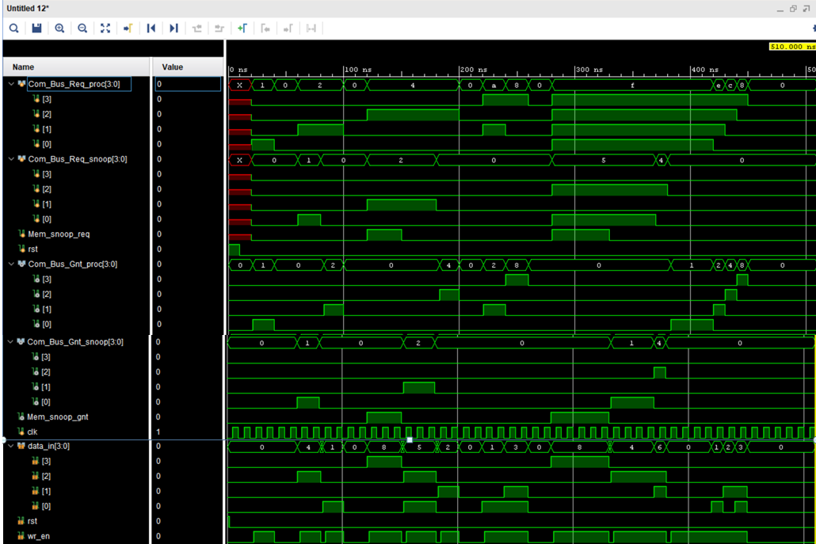

All tests passed!